**Step Up Boost Regulator or Converter**

Step-up boost converter basics

The boost converter circuit has many similarities to the buck converter. However the circuit topology for the boost converter is slightly different. The fundamental circuit for a boost converter or step up converter consists of an inductor, diode, capacitor, switch and error amplifier with switch control circuitry.

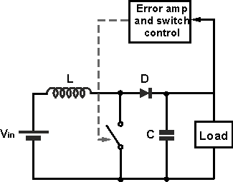

The circuit for the step-up boost converter operates by varying the amount of time in which inductor receives energy from the source.

In the basic block diagram the operation of the boost converter can be seen that the output voltage appearing across the load is sensed by the sense / error amplifier and an error voltage is generated that controls the switch.

Typically the boost converter switch is controlled by a pulse width modulator, the switch remaining on of longer as more current is drawn by the load and the voltage tends to drop and often there is a fixed frequency oscillator to drive the switching.

Boost converter operation

The operation of the boost converter is relatively straightforward.

When the switch is in the ON position, the inductor output is connected to ground and the voltage Vin is placed across it. The inductor current increases at a rate equal to Vin/L.

When the switch is placed in the OFF position, the voltage across the inductor changes and is equal to Vout-Vin. Current that was flowing in the inductor decays at a rate equal to (Vout-Vin)/L.

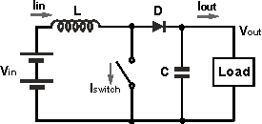

Referring to the boost converter circuit diagram, the current waveforms for the different areas of the circuit can be seen as below.

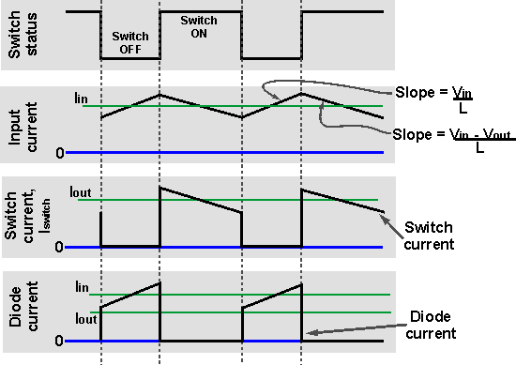

It can be seen from the waveform diagrams that the input current to the boost converter is higher than the output current. Assuming a perfectly efficient, i.e. lossless, boost converter, the power out must equal the power in, i.e. Vin ⋅ Iin = Vout ⋅ Iout. From this it can be seen if the output voltage is higher than the input voltage, then the input current must be higher than the output current.

In reality no boost converter will be lossless, but efficiency levels of around 85% and more are achievable in most supplies.

# Step Down Buck Regulator / Converter

Linear step down

The most basic form of step down transition is to use a resistor as a potential divider or voltage dropper. In some cases a zener diode may also be used to stabilise the voltage.

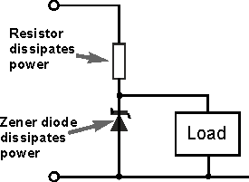

The issue with this form of voltage dropper or step down converter is that it is very wasteful in terms of power. Any voltage dropped across the resistor will be dissipated as heat, and any current flowing through the zener diode will also dissipate heat. Both of these elements result on the loss of valuable energy.

Basic buck converter or regulator

The fundamental circuit for a step down converter or buck converter consists of an inductor, diode, capacitor, switch and error amplifier with switch control circuitry.

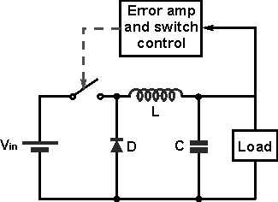

The circuit for the buck regulator operates by varying the amount of time in which inductor receives energy from the source.

In the basic block diagram the operation of the buck converter or buck regulator can be seen that the output voltage appearing across the load is sensed by the sense / error amplifier and an error voltage is generated that controls the switch.

Typically the switch is controlled by a pulse width modulator, the switch remaining on of longer as more current is drawn by the load and the voltage tends to drop and often there is a fixed frequency oscillator to drive the switching.

Buck converter operation

When the switch in the buck regulator is on, the voltage that appears across the inductor is Vin - Vout. Using the inductor equations, the current in the inductor will rise at a rate of (Vin-Vout)/L. At this time the diode D is reverse biased and does not conduct.

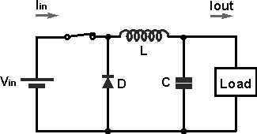

When the switch opens, current must still flow as the inductor works to keep the same current flowing. As a result current still flows through the inductor and into the load. The diode, D then forms the return path with a current Idiode equal to Iout flowing through it.

With the switch open, the polarity of the voltage across the inductor has reversed and therefore the current through the inductor decreases with a slope equal to -Vout/L.

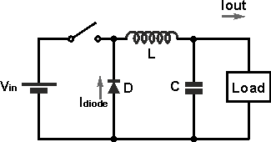

The step down, buck converter circuit can be further explained by examining the current waveforms at different times during the overall cycle.

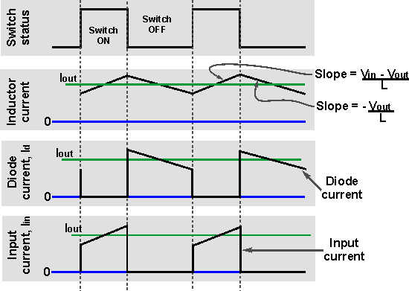

In the diagram of the current waveforms for the buck converter / switching regulator, it can be seen that the inductor current is the sum of the diode and input / switch current. Current either flows through the switch or the diode.

It is also worth noting that the average input current is less than the average output current. This is to be expected because the buck converter circuit is very efficient and the input voltage is greater than the output voltage. Assuming a perfect circuit, then power in would equal power out, i.e. Vin ⋅ In = Vout ⋅ Iout. While in a real circuit there will be some losses, efficiency levels greater than 85% are to be expected for a well-designed circuit.

It will also be seen that there is a smoothing capacitor placed on the output. This serves to ensure that the voltage does not vary appreciable, especially during and switch transition times. It will also be required to smooth any switching spikes that occur.

Regulator input and output filtering

A key aspect of switch mode power supply regulators is the input and output filtering. This is a particular issue because of the switching that occurs at the input.

In reality ripple voltage on the output is dependent not only on the output smoothing, but more importantly on an input filter capacitor.

## Buck Boost Converter

It is a type of [DC to DC converter](https://www.elprocus.com/boost-converters/)and it has a magnitude of output voltage. It may be more or less than equal to the input voltage magnitude. The buck boost converter is equal to [the fly back circuit](https://www.elprocus.com/freewheeling-or-flyback-diode-circuit-working-functions/)and single inductor is used in the place of the transformer. There are two types of converters in the buck boost converter that are buck converter and the other one is boost converter. These converters can produce the range of output voltage than the input voltage. The following diagram shows the basic buck boost converter.

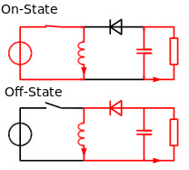Buck Boost Converter

### Working principle of Buck Boost Converter

The working operation of the DC to DC converter is the inductor in the input resistance has the unexpected variation in the input current. If the switch is ON then the inductor feed the energy from the input and it stores the energy of magnetic energy. If the switch is closed it discharges the energy. The output circuit of the capacitor is assumed as high sufficient than the time constant of an RC circuit is high on the output stage. The huge time constant is compared with the switching period and make sure that the steady state is a constant output voltage Vo(t) = Vo(constant) and present at the load terminal.

There are two different types of working principles in the buck boost converter.

* Buck converter.
* Boost converter.

### Buck Converter Working

The following diagram shows the working operation of the buck converter. In the buck converter first transistor is turned ON and second transistor is switched OFF due to high square wave frequency. If the gate terminal of the first transistor is more than the current pass through the magnetic field, charging C, and it supplies the load. The D1 is[the Schottky diode](https://www.elprocus.com/schottky-diode-working-and-applications/) and it is turned OFF due to the positive voltage to the cathode.

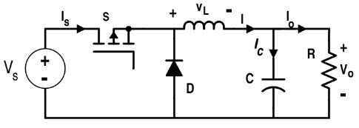Buck Converter Working

The inductor L is the initial source of current. If the first transistor is OFF by using the control unit then the current flow in the buck operation. The magnetic field of the inductor is collapsed and the back e.m.f is generated collapsing field turn around the polarity of the voltage across the inductor. The current flows in the diode D2, the load and the D1 diode will be turned ON.

The discharge of the inductor L decreases with the help of the current. During the first transistor is in one state the charge of the accumulator in the capacitor. The current flows through the load and during the off period keeping Vout reasonably. Hence it keeps the minimum ripple amplitude and Vout closes to the value of Vs

### Boost Converter Working

In this converter the first transistor is switched ON continually and for the second transistor the square wave of high frequency is applied to the gate terminal. The second transistor is in conducting when the on state and the input current flow from the inductor L through the second transistor. The negative terminal charging up the magnetic field around the inductor. The D2 diode cannot conduct because the anode is on the potential ground by highly conducting the second transistor.

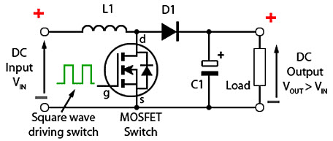Boost Converter Working

By charging the capacitor C the load is applied to the entire circuit in the ON State and it can construct earlier oscillator cycles. During the ON period the capacitor C can discharge regularly and the amount of high ripple frequency on the output voltage. The approximate potential difference is given by the equation below.

**VS + VL**

During the OFF period of second transistor the inductor L is charged and the capacitor C is discharged. The inductor L can produce the back e.m.f and the values are depending up on the rate of change of current of the second transistor switch. The amount of inductance the coil can occupy. Hence the back e.m.f can produce any different voltage through a wide range and determined by the design of the circuit. Hence the polarity of voltage across the inductor L has reversed now.

The input voltage gives the output voltage and atleast equal to or higher than the input voltage. The diode D2 is in forward biased and the current applied to the load current and it recharges the capacitors to VS + VL and it is ready for the second transistor.

The flyback converter is a power supply topology that uses mutually coupled inductor, to store energy when current passes through and releasing the energy when the power is removed. The flyback converters are similar to the booster converters in architecture and performance. However, the primary winding of the transformer replaces inductor while the secondary provides the output. In the flyback configuration, the primary and secondary windings are utilized as two separate inductors.

## Principle of operating of a flyback converter

When the current flowing through an inductor is cut off, the energy stored in the magnetic field is released by a sudden reversal of the terminal voltage. If a diode is in place to conduct the stored energy somewhere useful, the diode is called a flyback diode. This only requires one winding on the inductor, so the inductor would be called a flyback transformer. This arrangement has the interesting property of transferring energy to the secondary side of the power supply only when the primary switch is off.

The basic flyback converter uses a relatively small number of components. A switching device chops the input DC voltage and the energy in the primary is transferred to the secondary through the switching transformer. A diode in the secondary rectifies the voltage while the capacitor smoothes the rectified voltage. In a practical circuit, a feedback circuit is used to monitor the output voltage and while a control circuit switching device.

